Unit 6 Assignment
Name:Joseph Angelo O. Japitana Date: 10/28/2026
Year and Section: BSIT 3-B
Note: Upload your Flutter project to your assigned folder here -> https://github.com/WVSU-BSIT-Batch-2028/CC-207B_26-27_Activities. Read the instructions on submitting, including the file name/folder conventions in the GitHub repository.

I. CICT Org Fair App Development part 2. CICT wants more: a My Orgs page with everything you joined, the booth schedule for fair day, a grid view for wide screens, filter chips, an About page in a drawer, and tabs on each org with its officers and events. The starter already has your Part 1 app working plus most of the new screens. Your job is to finish 13 small pieces, explain how the navigation and layouts work, and run experiments that show what breaks when you leave a piece out. Most of your grade comes from understanding, not from typing. (35 points)
Get the initial Flutter project source code from: https://github.com/WVSU-BSIT-Batch-2028/CC-207B_26-27_Samples/tree/main/Unit%206/assignment_org_fair_2

Here is the table specifying the code changes you need to perform (included in the base source code):
File | What it does | What you do
lib/main.dart | Starts the app, sets the theme and the named route /about | Read
lib/data/orgs.dart | Same as Part 1: the orgs and the fake server | Read only. Do not change
lib/data/fair_data.dart | NEW. Officers, events and the booth schedule | Read only. Do not change
lib/models/membership.dart | NEW. One joined org plus the form used to join it | Read
lib/screens/home_shell.dart | NEW. NavigationBar with Orgs, My Orgs and Schedule. Owns the memberships | TODO 1 to 4; E1, E2
lib/screens/org_list_screen.dart | Part 1 list, plus a drawer, category chips and a list/grid button | TODO 5 to 9; E3 to E5
lib/screens/org_detail_screen.dart | One org, now in tabs: About, Officers, Events | TODO 10, 11; E6
lib/screens/my_orgs_screen.dart | NEW. The orgs you joined, with a Leave button | TODO 12; E7
lib/screens/schedule_screen.dart | NEW. The booth schedule as a Table | TODO 13; E8
lib/screens/about_screen.dart | NEW. Opened by name from the drawer. Uses a Stack | Read
lib/widgets/org_tile.dart | NEW. One org in the grid (Stack with a star on the banner) | Read
lib/screens/join_form_screen.dart, lib/widgets/ (others) | Same as Part 1 | Read
test/org_fair_test.dart | 9 automatic tests. Each one names the TODOs it checks | Run to check your work
Note: Run the command “flutter test” at any time. All tests should pass before submitting the assignment.

The finished application should look something like these:
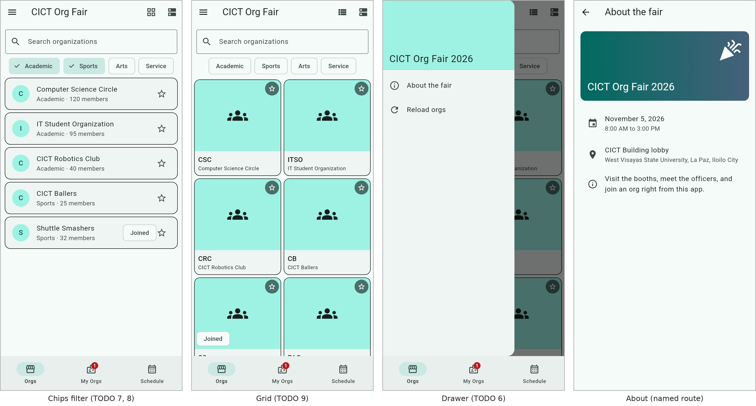
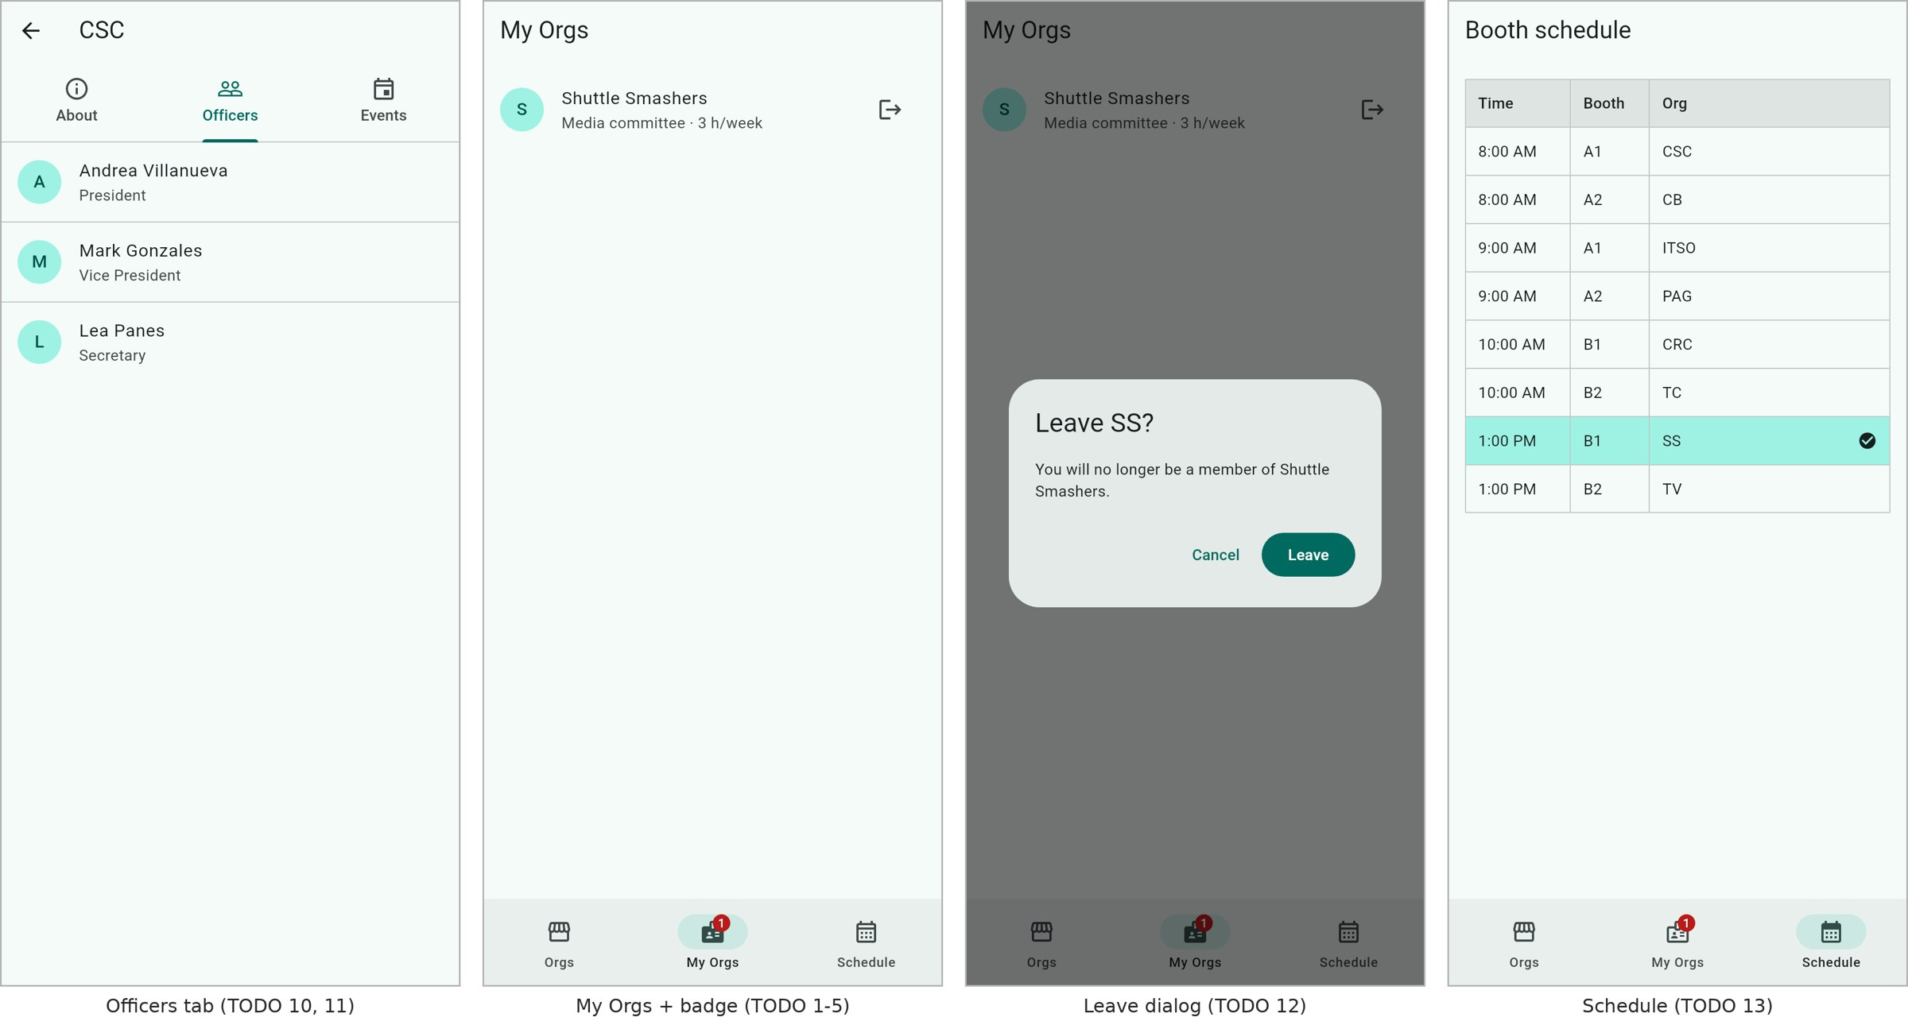

Each TODO is a comment in the code with a placeholder line under it. Replace the placeholder with your code. Most need 1 to 5 lines. 3 points each. (39 points total).
# | File | What to do | Slide
1 | home_shell | Show the selected page with an IndexedStack so every page stays alive | 71 NavigationBar
2 | home_shell | onDestinationSelected: switch tabs with setState | 71 NavigationBar
3 | home_shell | A Badge on the My Orgs icons with the number of joined orgs, hidden at 0 | 71 (Badge: see the Flutter docs)
4 | home_shell | _join: save the membership in the map with setState | 57 Passing data and results
5 | org_list_screen | Pass the new membership up with widget.onJoined | 57 Passing data and results
6 | org_list_screen | Drawer item: close the drawer, then pushNamed the About screen | 53 to 56, 64 Drawer
7 | org_list_screen | _toggleCategory: add or remove the category with setState | Unit 5 setState; 26 Wrap
8 | org_list_screen | Keep only the orgs in the selected categories (all when none is selected) | Unit 5 search filter
9 | org_list_screen | Grid columns from the width: SliverGridDelegateWithMaxCrossAxisExtent | 36, 40 GridView
10 | org_detail_screen | Add the Officers tab: a Tab, a TabBarView child and the right length | 65 to 68 Tabs
11 | org_detail_screen | The officers in a ListView.separated with a Divider between them | 29 ListView
12 | my_orgs_screen | Ask with showDialog<bool> before leaving an org | 58 Dialogs
13 | schedule_screen | Highlight the rows of joined orgs with a BoxDecoration | 44 to 46 Table

The code has 8 comments that start with EXPLAIN E1 to EXPLAIN E8. Answer each one in the README.md of your project in 2 to 4 sentences, in your own words, and point to the line you are talking about (file and line number). 3 points each. (24 points total)
# | Where | The question is about
E1 | home_shell: _memberships | Lifting state up: why the joined orgs live in HomeShell
E2 | home_shell: body | Why IndexedStack keeps your search text when you switch tabs
E3 | org_list_screen: drawer | Why the drawer is closed before the About screen opens
E4 | org_list_screen: chips | Wrap or Row when the chips do not fit
E5 | org_list_screen: _buildGrid | The column math of maxCrossAxisExtent
E6 | org_detail_screen | What must match in DefaultTabController, TabBar and TabBarView
E7 | my_orgs_screen: _confirmLeave | Why a dialog answer is bool? and is tested with == true
E8 | schedule_screen | Why a Table and not a Column of Rows

Answer:
E1:
(home_shell.dart, line 25, _memberships)
The three tabs need the same org data, so I kept it in HomeShell, their common parent. This lets me share the data with all three screens.
E2:
(home_shell.dart, line 60, body: IndexedStack())
IndexedStack keeps all three pages loaded even when I switch tabs. This way, the search bar and other page data don't reset.
E3:
(org_list_screen.dart, line 128, "About the fair" ListTile)
I close the drawer first before opening the About page to avoid leaving it open underneath. If I open About first, the drawer may show again when I go back.
E4:
(org_list_screen.dart, line 260, Wrap of FilterChips)
I used Wrap so the filter chips can move to the next line when there's not enough space. Using Row could make the chips overflow the screen.
E5:
(org_list_screen.dart, line 289, _buildGrid)
The grid adjusts the number of columns based on the screen width, giving 2 columns on a 360-wide phone and 5 on a 1000-wide window. Each tile becomes 168 and 190.4 wide, respectively, keeping them within the 200 max width.
E6:
(org_detail_screen.dart, line 32, DefaultTabController)
The controller, tabs, and pages should all have the same count, which is 3 in this case. If they don't match, Flutter shows an error because the tabs and pages won't line up.
E7:
(my_orgs_screen.dart, line 23, _confirmLeave)
The dialog can return true, false, or null if the user closes it without choosing. I used confirmed == true so the org is only left when the user actually presses "Leave."
E8:
(schedule_screen.dart, line 53, Table)
I used Table so the Time, Booth, and Org columns stay properly aligned. Using separate Rows could make the columns uneven if the text lengths are different.

Evidence (Provide screenshots of the application to show that it is working):
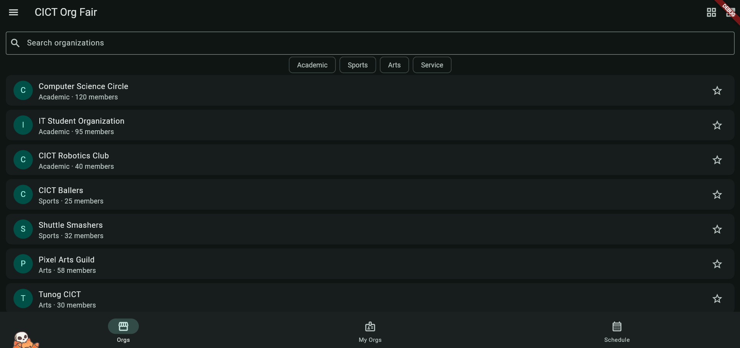
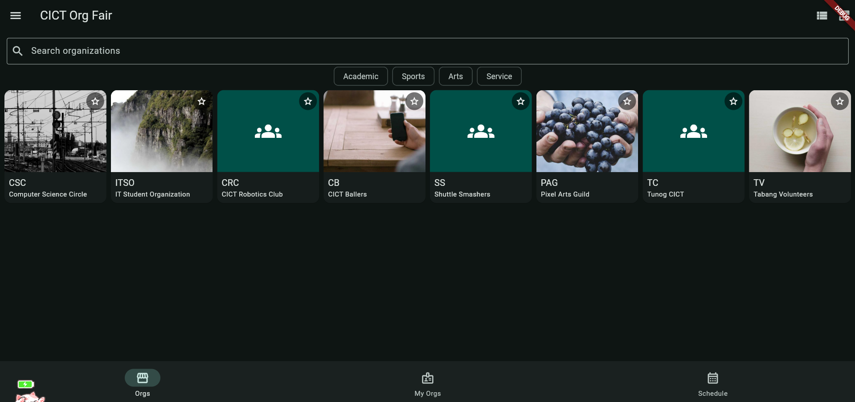
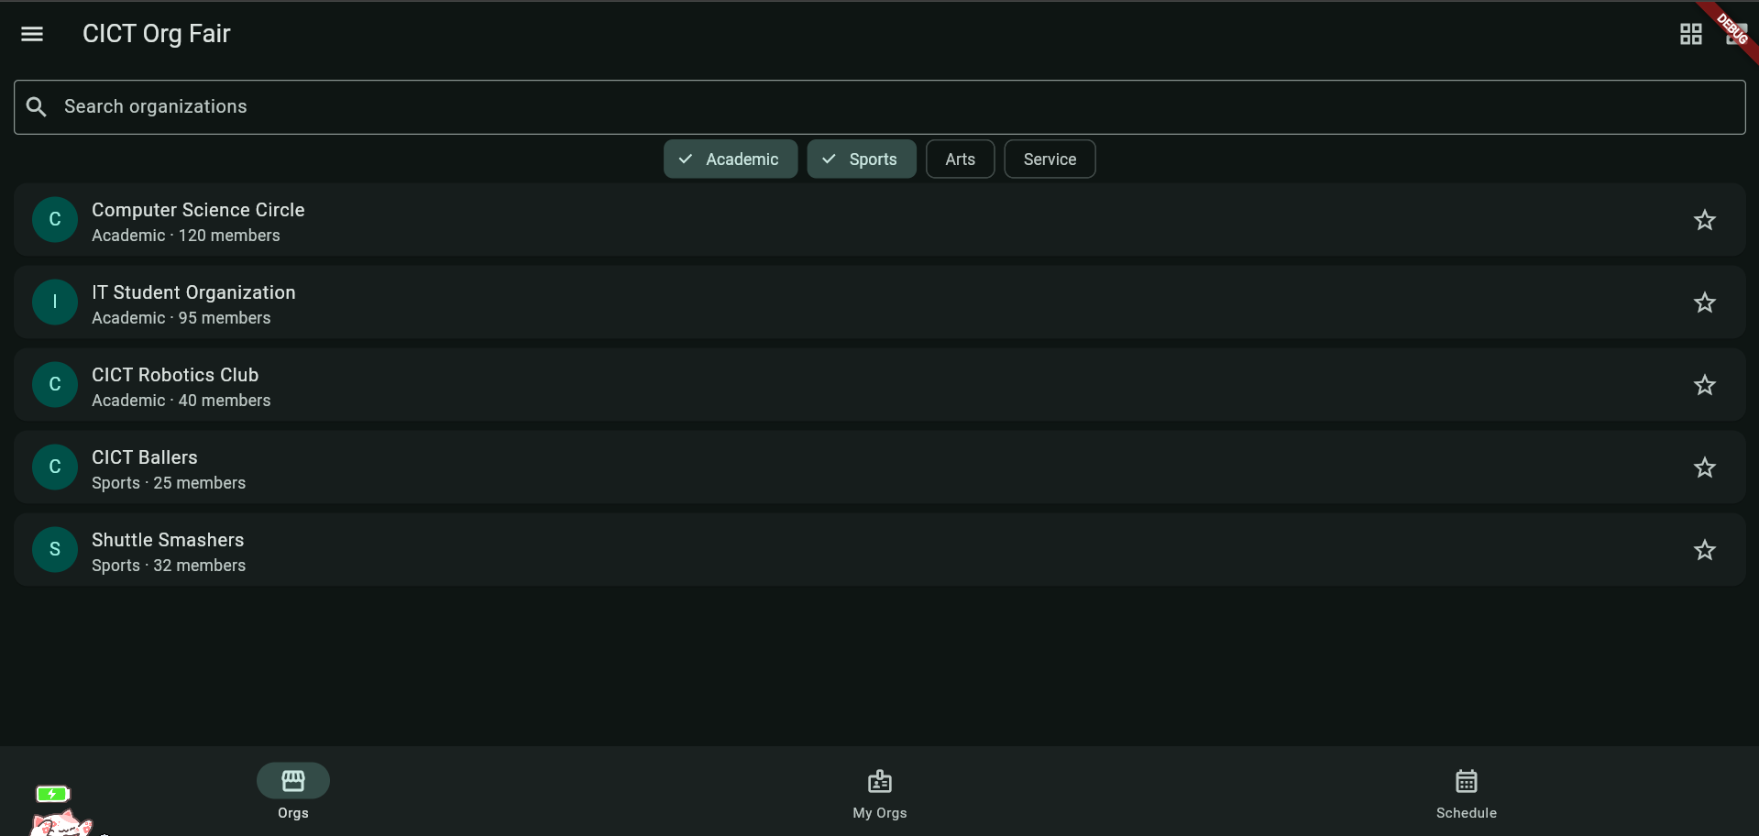
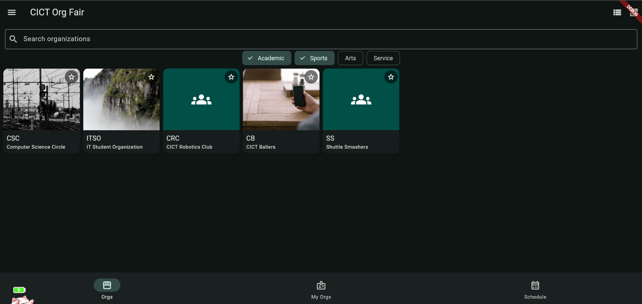
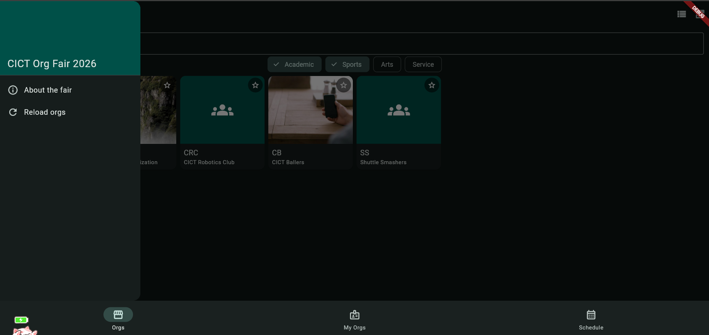
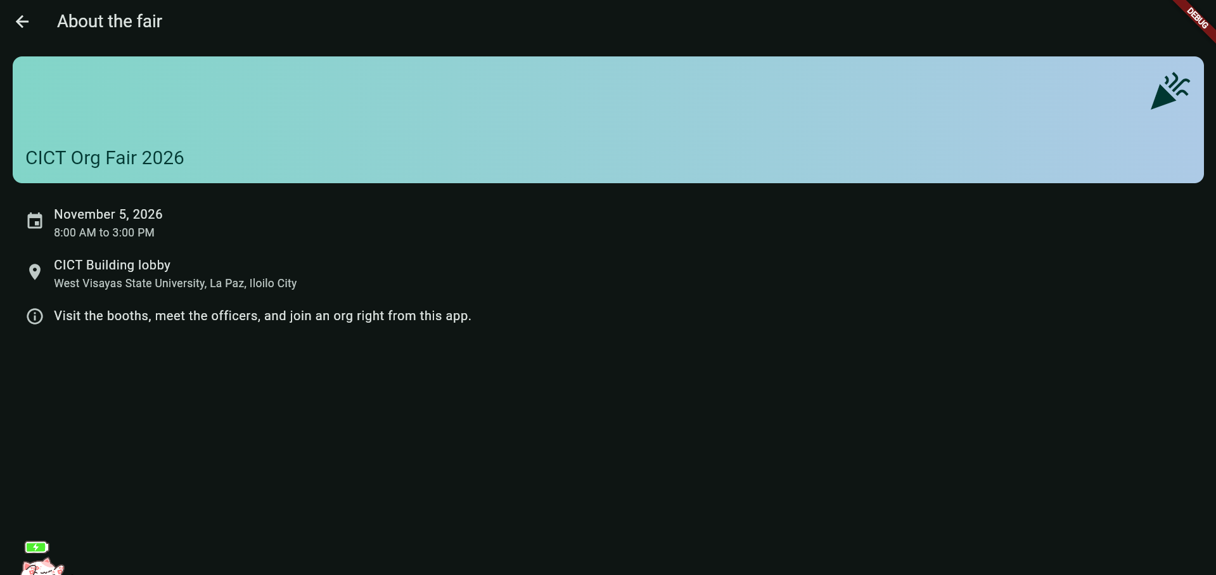
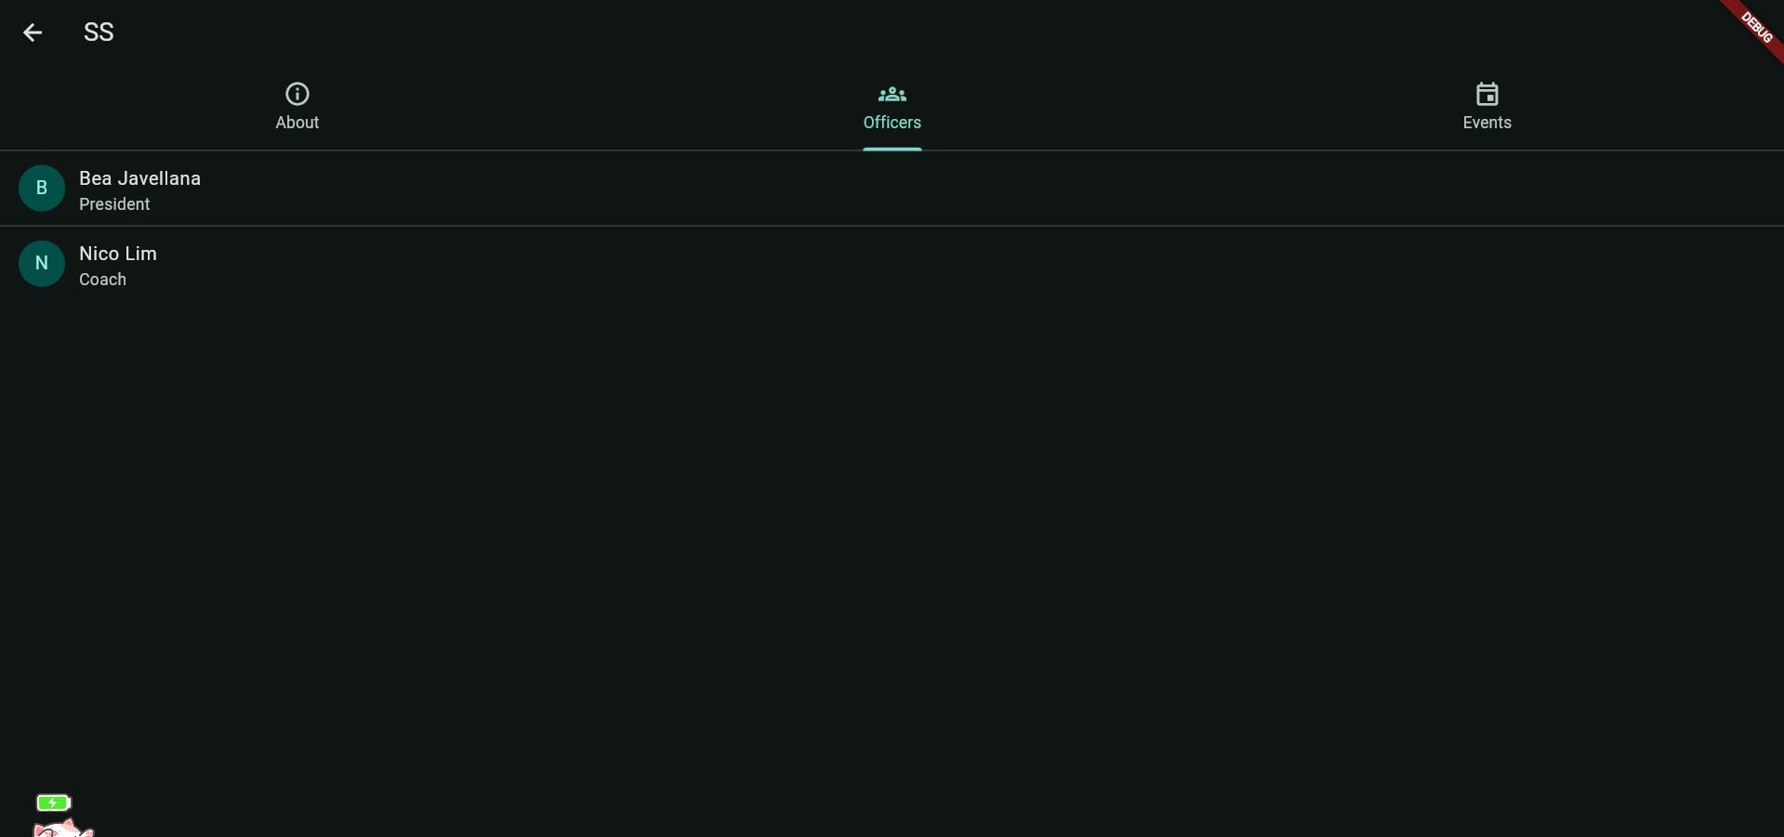
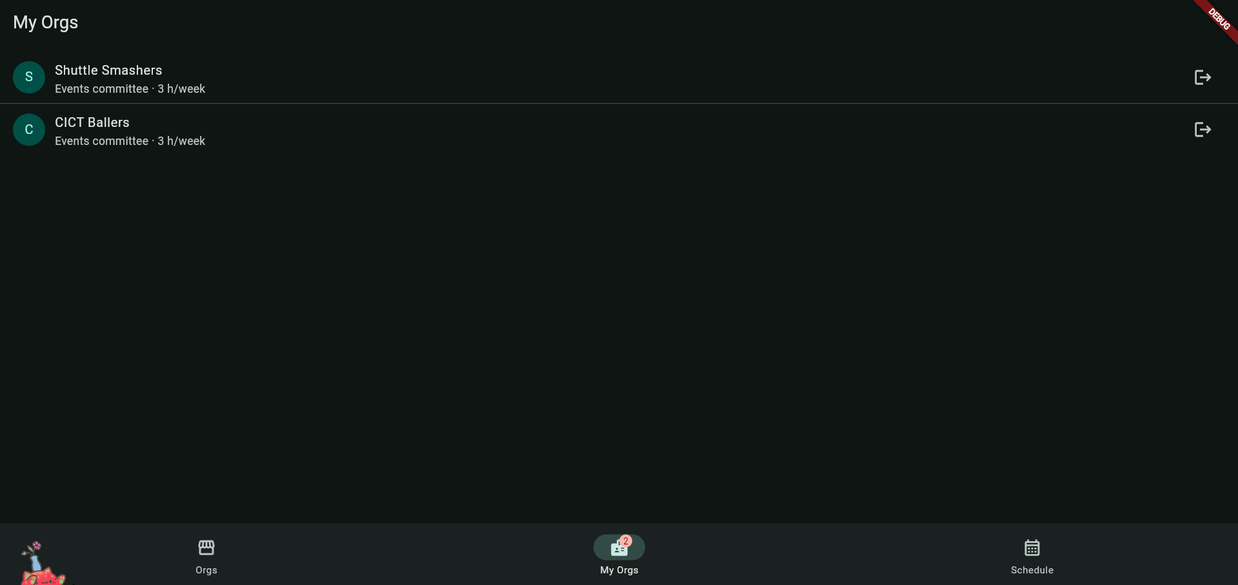
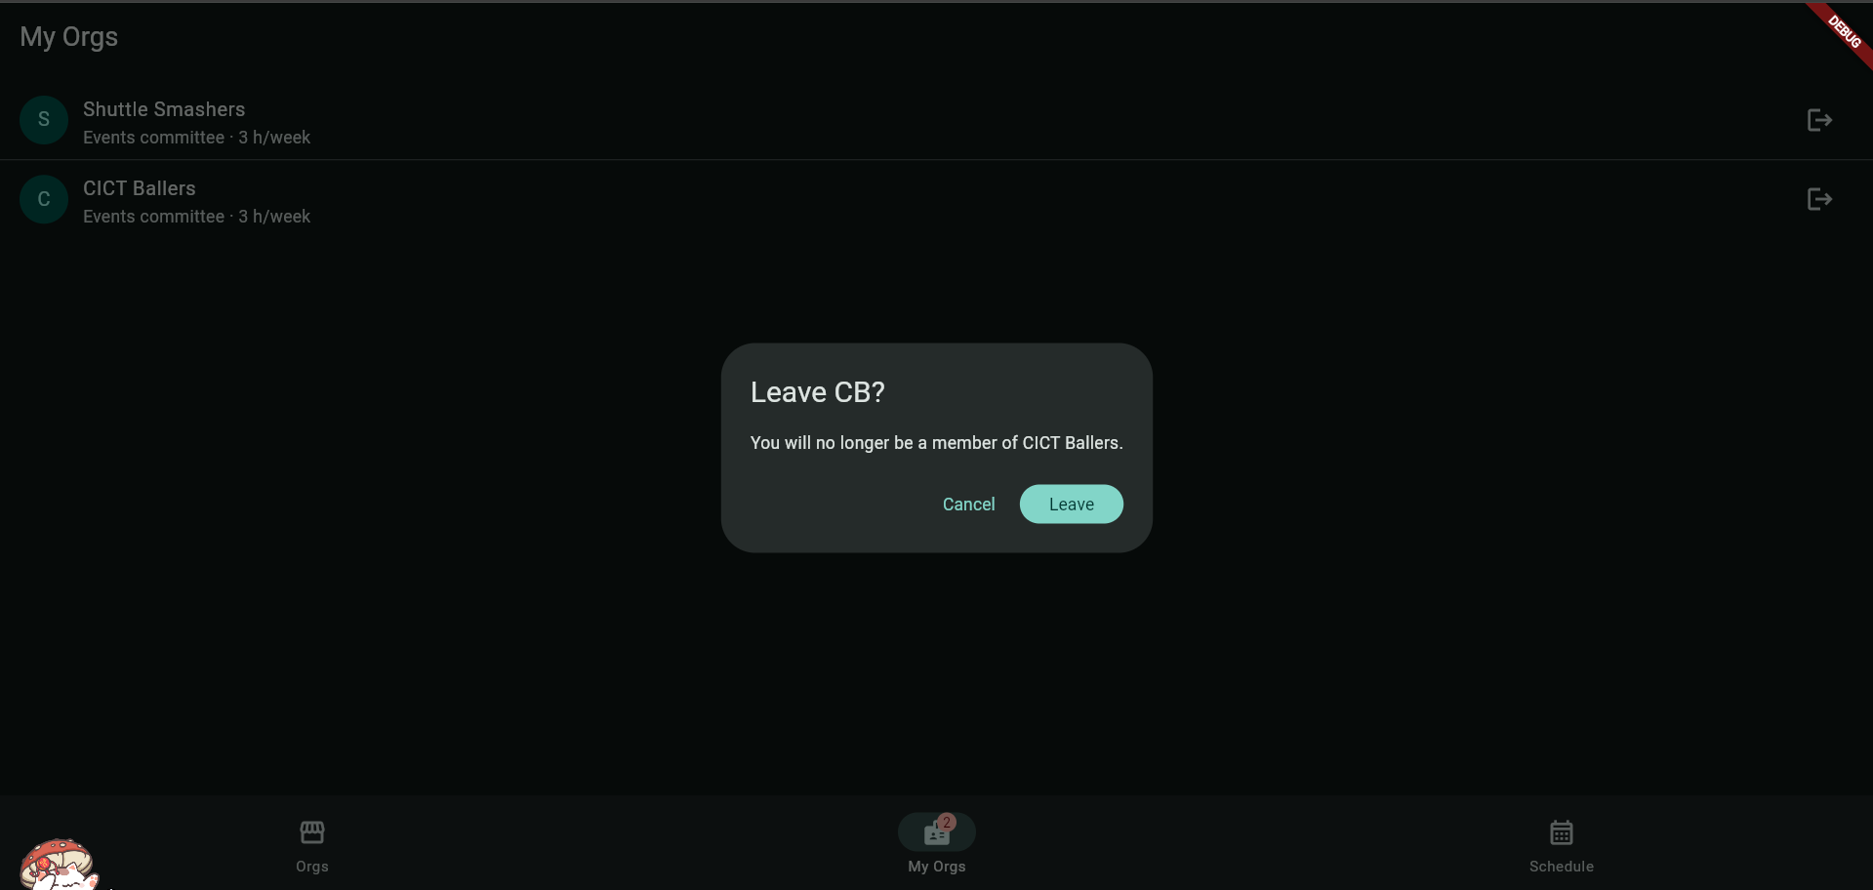
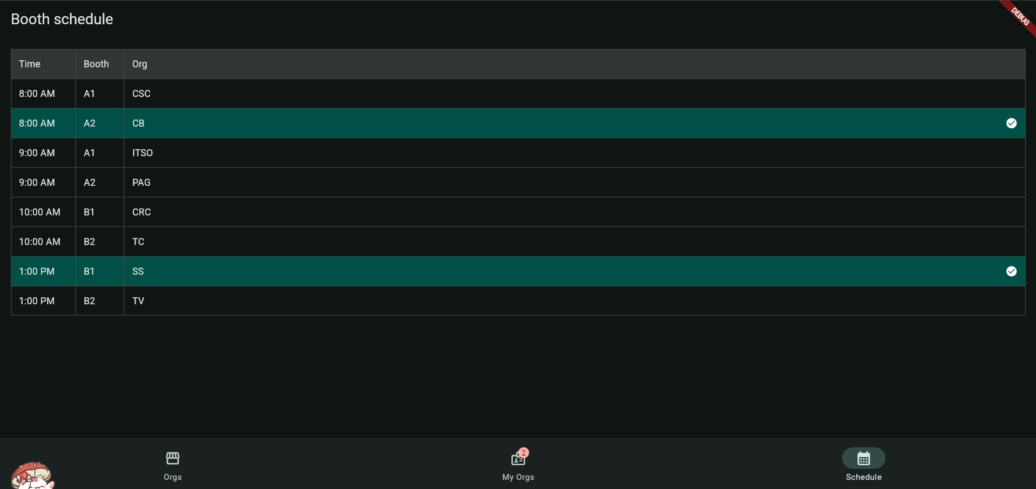

II. CICT Org Fair Code Analysis. The code has 11 comments that start with EXPLAIN E1 to EXPLAIN E11. Put your answers in the available column for each row. (2 points each)
# | Where | The question is about | Answer
E1 | main.dart | Why OrgFairApp is stateless but OrgListScreen is stateful? | OrgFairApp only holds the repo and sets the theme and routes, and nothing in it changes while the app runs. OrgListScreen has changing data so it needs a State.
E2 | org_list_screen: dispose() | Why controllers must be disposed? | The TextEditingController holds resources and listeners. dispose() releases them when the screen is removed, so they don’t leak memory.
E3 | org_list_screen: FutureBuilder | The order of states when the user presses Try again? | “Try again” calls _reload, which assigns a new future in setState. FutureBuilder goes from the error state to loading, then to done with data or an error.
E4 | org_list_screen: _buildOrgs | How the list updates while the user types? | Each keystroke calls onChanged, which runs setState and updates _query. _buildOrgs then filters the orgs again, so the list updates as the user types.
E5 | org_list_screen: Expanded | Constraints go down, sizes go up? | The Column gives its children unbounded height, and Expanded gives the list the remaining space as a fixed constraint. The list then sizes itself inside that. Without Expanded, a ListView in a Column gets unbounded height and throws an error.
E6 | org_card.dart | Where the favorite star's state lives? | In _OrgListScreenState, in the _favoriteIds set. OrgCard is stateless: it receives isFavorite and reports long-presses through onLongPress.
E7 | org_list_screen: _openDetail | How data comes back from another screen? | _openDetail awaits Navigator.push<Registration>, and the detail screen returns data with Navigator.pop. The result is null if the user goes back without joining.
E8 | org_banner.dart | Null safety and the loading and error builders? | bannerUrl is String? because some orgs have no photo. The code copies it to a local url and checks for null, showing a placeholder if it is null. loadingBuilder shows a spinner while the image loads, and errorBuilder shows a broken-image icon if it fails.
E9 | org_detail_screen: _join | Why check context.mounted after await? | After an await, the screen may already be closed, so its context may be invalid. Checking context.mounted before Navigator.pop avoids using a dead context.
E10 | join_form_screen: _formKey | What a GlobalKey<FormState> gives you? | It gives access to the form’s state from outside the form. _formKey.currentState! is used to validate(), save() and reset() all the fields at once.
E11 | join_form_screen: autovalidateMode | When errors should appear? | With AutovalidateMode.onUserInteraction, errors only appear after the user has touched a field. The form doesn’t open full of red messages, and they update as the user types.

Determine what type of widgets and whether they are either stateless or stateful. (2 points each)
Feature | Widget(s) used | Stateless or Stateful? Why?
Org list or grid | OrgListScreen with ListView.builder / GridView.builder, showing OrgCard / OrgTile | Stateful, it owns the search query, chips, favorites and the grid toggle. The cards and tiles are stateless and only display what they receive.
Favorite star | Icon (star) inside OrgCard | Stateless. The star’s state lives in the parent’s _favoriteIds, and the card is rebuilt with a new isFavorite.
Banner image | OrgBanner with Image.network | Stateless. It only displays the image for the org it is given, and the image loading is handled inside Image.network.
Submit button | FilledButton in JoinFormScreen | Stateless, but it is enabled by _agreed (onPressed: _agreed ? _submit : null), which lives in the stateful JoinFormScreen’s State.

